COUNTY OF PRINCE WILLIAM
5 County Complex Court, Suite 170
Prince William, Virginia 22192-5308 DEPARTMENT OF
(703) 792-7070 Metro 631-1703 FAX: (703) 792-6297 PUBLIC WORKS
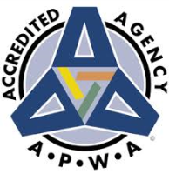
Environmental
Services Division
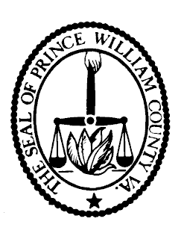
Thomas Bruun

Director

OWNER ACKNOWLEDGEMENT FORM
Date: _____________________

Lot Grading Plan Number:
Waiver Number:
Property Address:
Subdivision / Section & Phase / Lot Number:
Builder / Developer Name and Address:

I am the contract purchaser / owner of the above referenced property. I understand that the driveway slope for this lot does not meet the requirements of Prince William County’s Design Construction Standards Manual (DCSM).

I am requesting Prince William County to approve a waiver of these requirements and I accept all responsibilities for any problems that may occur as a result of the non-standard driveway slope. Possible problems include, but are not limited to the following:
- A steep, icy slope during winter
- Ponding of water if the slope is too flat
- Undercarriages of vehicles coming into contact with the pavement
- A slope that may be too steep to be negotiated by pedestrians, etc.

Name (Printed):
Signature:
Date:

This form must be attached to the driveway waiver application.

